**AIM: PROJECT ANALYSIS**



***MyHome - IoT Based Smart Home Automation System***

***Submitted to: Ms. Monali Rajput***

***Submitted by: Narender Keswani(24) & Prathamesh Bhosale(10)***

***FYMCA-B***

**USER ANALYSIS:**

User analysis is the process by which engineers, developers, and designers track how users engage and interact with their software, product, or application in an attempt to improve their product, bring more users in, improve user engagement with their product, and the general success of their application.

To make sure you focus on the right metrics and know how to use the information you gather properly, you must first understand why user analysis is so important, and what you stand to gain from tracking user behaviours. Here are the main reasons:

* **Understand how users engage with your product:** Learn the features that are most popular, how and why the product is used the way it is, and what your users want from it
* **Develop user profiles based on user actions and attributes:** Establishing distinct personas will help you understand how different groups of users interact with your solution, which can help you design a more appealing product for each group
* **Gather quantifiable data on your users**—This allows you to identify, detect, and eventually predict trends and behaviour by users
* **Product design and development:** Making the right decisions based on informed metrics tracking and a detailed customer roadmap will improve decision making as it relates to design changes, new/updated features, and onboarding strategy
* **Analyze and apply information:** Product design and development updates affect user experience, retention, churn, and conversion, so using your data to inform this decision making is key to your success

## The user analysis process from start to finish

Product design and development is a continuous process. From creation, it should be an endless cycle of receiving, analysing, and applying feedback to make the product better. This information can come in various forms, including surveys, data analytics, and customer feedback. Use each source as needed, making sure to track the metrics that matter most to your software, product, or application.

**Step 1: Survey:**

We started off the process by creating a survey using google forms to send out to as many people as possible — we did not have an initial target audience as this was discovery exercise to collate **quantitative data.**

**Survey Questions:**

1. Have you ever heard term “home automation” or “smart home”?
2. Do you ever forget to switch off the electrical appliance?
3. Do you ever worry about household electricity bills?
4. Do you ever forget to put water in plant?
5. Do you ever worry when your water tank overflow?
6. Do you ever worry when any gas leakage or fire is there?
7. Would you prefer switching on / switching off the electrical appliances via an android app remotely?
8. Would you prefer to get notified when the plant needs water?
9. Would you prefer live tracking of water tank levels via an android app?
10. Would you prefer live tracking of electricity usage via an android app?
11. Would you prefer electrical appliances that will switch on / switch off automatically according to fixed days & time?
12. Would you prefer to get notified when any gas leakage or fire is there?
13. How often you use these devices and how is your experience with these devices?
14. Do you use one application to manage all the devices? If yes then which application?
15. What problems do you face while managing these devices from the smart home ecosystem?
16. Are you able to manage your house security and safety with the use of this system?
17. Will you prefer a system where all your devices can be managed together, including installations, onboarding, and usage?

**Survey Insights:**

1. Users want to manage all the smart home products from one application including onboarding of the product and installation.
2. The application takes a long time to detect the products and to display the correct data and state of the product.
3. Users prefer to be in charge of all the devices and want to speed up the detection process.
4. Users want the smart home ecosystem to act intelligently and give different scenarios according to the user’s preferences and behaviours.

## **Step 2: Starting with personas**

The number of people using your product is not the only thing you need to consider in the designing stages of your product. Knowing who is using your product, and the user paths they follow within your software or application is important for improving engagement.

Develop user personas by identifying characteristics, attributes, and behavior of your users/customers. These personas are meant to represent a collection of people that fit these categories, and represents your users in a general, but in a quantifiable way. It’s best to name these personas so they are easy to work with. User personas help you envision your target audience, allowing you to draw in more users, keep them happier, and increase your conversions!

**USER PERSONA #1:**

* Name: Mihr Agarwal
* Target Audience: 22 - 45 years
* Profile: Professional
* Location: Bangalore, India
* User Role: Customer

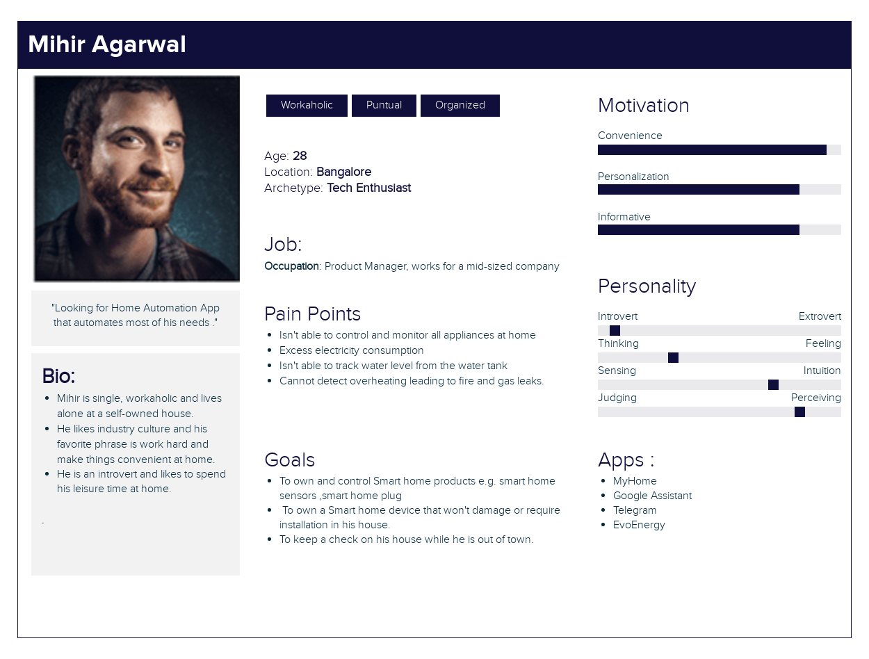

**USER PERSONA #2:**

* Name: Tanvi Chawla
* Target Audience: 22 - 45 years
* Profile: Household
* Location: Mumbai, India
* User Role: Customer

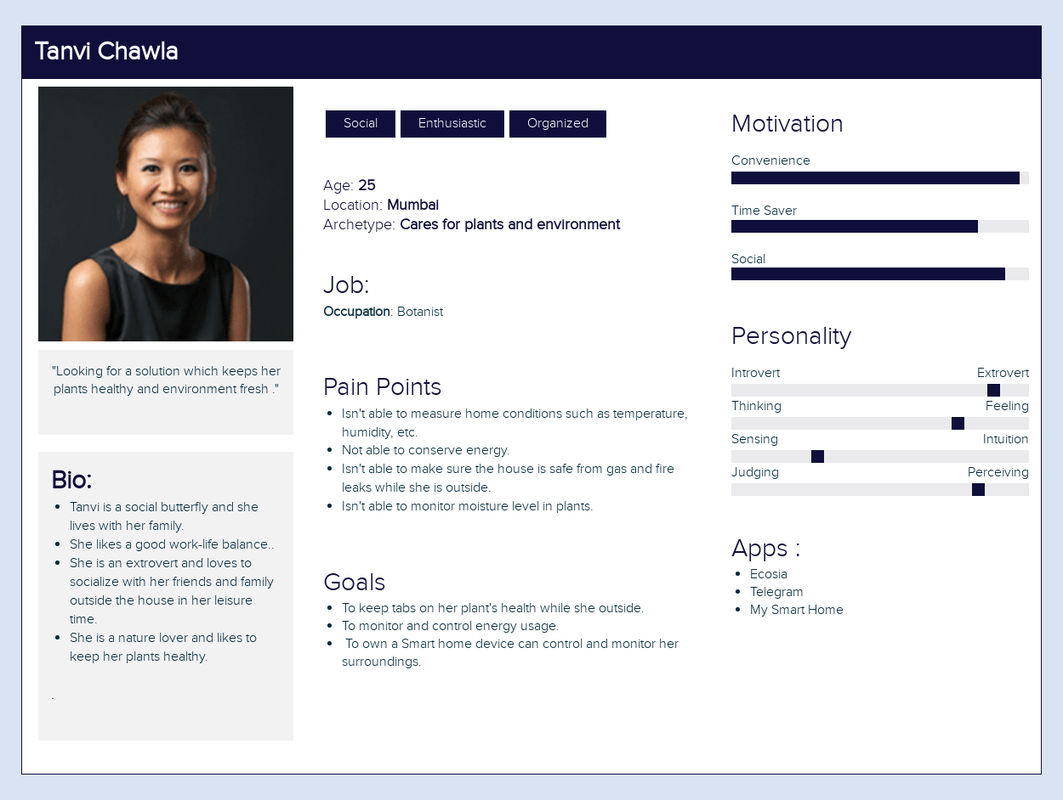

**USER PERSONA #3:**

* Name: Rahul Sharma
* Target Audience: 60+ years
* Profile: Senior Citizen Household
* Location: Mumbai, India
* User Role: Customer

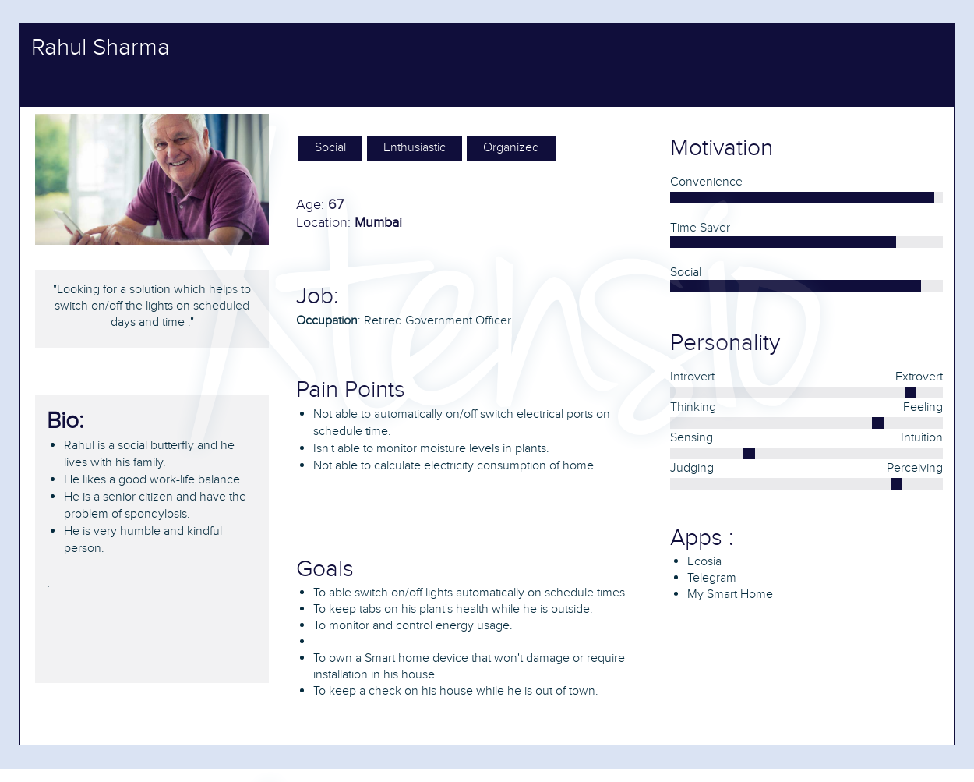

**PROBLEM STATEMENT:**

* Smart home residents tend to own multiple smart devices and want them to work together under a single app. They also want an option where devices could be scheduled to run by the user and be automated accordingly. Another feature most of them desired was sharing the access of devices and to have admin control over them.

**TARGET USERS:**

* The target users are homeowners wanting to track their energy management and corporate offices to automate devices on a larger scale.
* Users who are open to new technologies and likely to be early adopters of new products.
* Users who are in mid-carter and have an earning to own smart home.

**PROPOSED SYSTEM:**

1. **Electrical port switching (on/off):** User can switch ON the electrical ports and switch OFF the electrical ports. There will be total 4 ports.
2. **Automatic on/off the electrical ports:** User will select Days, Start Time, Stop Time for the particular electrical port. At selected days & time the electrical port will automatically turned ON & turned OFF.
3. **Electricity consumption monitoring:** User will get the real time consumption information in the mobile. User will get the information such as energy consumption, power consumption, current consumption, bill (in rs). User can see the graph of the consumption.
4. **Water tank measuring:** User can see the current water level of the tank on mobile. User will be notified when the water tank will be full.
5. **Air quality monitoring:** User can see the current indoor Temperature, Humidity and the AQI (Air Quality Index) on mobile.
6. **Plant monitoring:** User can see the current moisture level of the plant on mobile. User will be notified when the plant needs water.
7. **Gas detection**: User will be notified when any gas leakage is detected.
8. **Fire detection:** User will be notified when any fire is detected.
9. **Google assistant:** User will voice command to the Google Assistant and particular action will be performed.
10. **Technical assistant bot:** User will ask command questions to the bot and bot will process it.
11. **Telegram Bot: :** User will ask command questions to the telegram bot and telegram bot will process it.

**USER GOALS:**

* **Safety:** User will be notified when any fire or gas leakage is there.
* **Real time monitoring:** User will get to know electricity usage statistics, water tank level, plant moisture level.
* **Centralized system:** User will get all features of home automation at one platform.
* **Saves Time:** Everyone is living in busy environment; user don’t even have to worry about the home.
* **Ease for Disabled & Senior Citizens:** For Elderly & disabled people, simple tasks can become difficult. With features like voice command, home automation gives freedom and independence to the elderly.
* **Monitor from anywhere:** User can monitor their home from anywhere they just have to login.

**OBSTACLES / PAINPOINTS:**

* **User friendly experience** to identify and automate daily routine
* No efficient **energy management system** to keep track of the energy consumption
* No **real-time cost tracking system** which would allow users to track cost for their energy consumption
* No means to set up**routines** which will make users create an automated schedule for their devices, thereby enabling them to conserve energy and costs
* No **real-time system to** track water level from the water tank
* Cannot detect overheating leading to fire and gas leaks.

**DOMAIN ANALYSIS:**

* A domain is the targeted subject area of a computer program. It is a term used in software engineering. It’s a general field of business or technology in which the customers expect to be using the software.
* Domain analysis, or product line analysis, is the process of analyzing related software systems in a domain to find their common and variable parts. It is the process by which a developer learns background information.
* To perform domain analysis, you gather information from whatever sources of information are available: these include the domain experts; any books about the domain; any existing software and its documentation, and any other documents he or she can find. The interviewing, brainstorming, and use-case analysis techniques.

**Domain name:** MyHome Smart Home Automation Mobile Application

**Stakeholders:**

**User:**

User can be age of 18-80 which he/she can login in system and can control and monitor the home via mobile app and IoT.

**The environment:**

**FIGMA:** It is a web-based graphics editing and user interface design app. You can use it to do all kinds of graphic design work from wireframing websites, designing mobile app interfaces, prototyping designs, crafting social media posts, and everything in between.

Tasks and procedures to be performed:

1. User authentication via login.
2. User can switch ON the electrical ports and switch OFF the electrical ports. There will be total 4 ports.
3. User will select Days, Start Time, Stop Time for the particular electrical port. At selected days & time the electrical port will automatically turned ON & turned OFF.
4. User will get the real time consumption information in the mobile. User will get the information such as energy consumption, power consumption, current consumption, bill (in rs). User can see the graph of the consumption.
5. User can see the current water level of the tank on mobile. User will be notified when the water tank will be full.
6. User can see the current indoor Temperature, Humidity and the AQI (Air Quality Index) on mobile.
7. User can see the current moisture level of the plant on mobile. User will be notified when the plant needs water.
8. User will be notified when any gas leakage is detected.
9. User will be notified when any fire is detected.
10. User will voice command to the Google Assistant and particular action will be performed.
11. User will ask command questions to the bot and bot will process it.
12. User will ask command questions to the telegram bot and telegram bot will process it.

Competing software:

1. Smartlife:

PROS:

* It can add devices by both manually and scanning
* It can take voice command of the user and Optimize climate controls.
* Remotely lock and unlock doors.

1. FIBARO:

PROS:

* Push notification
* Possibility to change the icons for devices and rooms
* Possibility to display current power consumption

CONS:

* Inefficient navigation through rooms and devices
* Issues in the visual hierarchy.
* Invite others to location where devices are registered to enable shared control

**TASK ANALYSIS:**

Task analysis is the process of learning about ordinary users by observing them in action to understand in detail how they perform their tasks and achieve their intended goals.

So, after performing task analysis for MyHome we have come up with some basic and few new features for our users.

|  |  |  |
| --- | --- | --- |
| **Sr.no** | **Name** | **Description** |
| 1 | Spalsh Screen | This is the Splash screen which shows logo and loading animation. |
| 2 | Bottom Nav Bar | This is the main controller which will be displayed to the user after user logs in. This activity controls all the activities and fragments. Redirects it whenever user click on the event. This activity shows bottom navigation bar and side navigation drawer. Also, it manages the Shared Preferences of the user and other settings like parental control and logout, etc. |
| 3 | Dashboard | This is the main dashboard which shows Air monitoring and the control of the electrical ports. (Switching on and switching off) |
| 4 | Plant | This is a plant fragment which shows current moisture level of the plant and status of the plant. |
| 5 | Water | This is a water fragment which shows current water tank level with wave animation. |
| 6 | Report Problem | This a activity where user can report the problems and also give suggestions to the app developer. |
| 8 | Login | This is login activity where the user will enter the credentials. If credentials are correct then the user will be redirected to OTP Verification. |
| 10 | Otp Verification | This OTP verification activity will send an OTP to registered email address. If OTP is correct then it will be redirected to Main Controller. |
| 11 | Change Password | This Change Password Activity allows users to change the current password. Where user enters the old password and new password. |
| 12 | Edit Profile | This Edit profile Activity allows users to edit their names and email. |
| 13 | Forget Password | If the user forgets his/her password they can reset their reset their password using this activity. |
| 14 | Auto On Off | This Auto On Off Activity where user enter days, start time, stop time of the electrical port. The electrical port will be automatically on and off accordingly. |
| 16 | Last Month Electricity Usage | This fragment displays the Last Month’s Electricity Usage. (Current, Power, Bill, Energy) |
| 17 | This Month Fragment | This fragment displays the This Month’s Electricity Usage. (Current, Power, Bill, Energy) |
| 18 | Today Electricity Usage | This fragment displays the Today’s Electricity Usage. (Current, Power, Bill, Energy, Frequency, Voltage, Power Factor) |
| 19 | Last Month Electricity Usage Graph | This activity displays the Last Month’s Electricity Usage Bar Graph [Statistics]. (Current, Power, Bill, Energy) |
| 20 | This Month Electricity Usage | This activity displays the This Month’s Electricity Usage Bar Graph [Statistics]. (Current, Power, Bill, Energy) |
| 21 | On Boarding Screen | This On Boarding Activity is a one time description of the app which is showed to user. |
| 29 | Settings | This is a Settings Activity where user can edit settings and preferences accordingly. |
| 30 | Chat Bot | This activity will let user to connect with the chatbot where user can command the request and bot will generate response. |
| 31 | FAQ | This activity will display the in general question that is mostly asked by the users. |
| 32 | Privacy Policy | This activity contains privacy policy of using the app. |

**CONCLUSION:**

Complete analysis of the project is done by gathering proposed system and defining user goals and obstacles. User persona is also developed of the proposed system is described. We have successfully performed project analysis by sectioning it into user analysis, task analysis, and Domain analysis.